SIT 102 – INTRODUCTION TO PROGRAMMING
Introduction to python :
SUMMARY:
Python is a language known for its simplicity. It can support multiple programming paradigms, including procedural, object oriented and functional programming. Python has a range of third party packages and has a vast library which makes it suitable for a wide range of applications. Its syntax is easy to read which helps programmers write clear and maintainable code efficiently. Python eliminates the need for semicolons (;) at the end of statements and uses indentation instead of curly braces {} to define code blocks. This not only makes the code cleaner but enforces readability.
We do not need to declare variable types explicitly in python. It determines types at runtime which simplifies variable declarations but requires attention to avoid type mismatches.
We have some fundamental data types in python which are int, float, str and bool. In python, variables are assigned using equals (=) sign with the type inferred from the value.
We have basic operators in python:
Arithmetic : +, -, *, /, %, **
Comparison : == ,!=, <, >, <=, >=.
Logical : and, or, not.
Assignment: = , +=, -= , *=, /=.
Running the code and understanding the main function :
We can run our application in vs code by either using “run python file” by right clicking the editor or simply using f5 shortcut.
The line ‘if__name__==’__main__’; checks if our script is the main program being executed or if its imported as a module. When the script runs directly, this block executes.
Learning evidence :

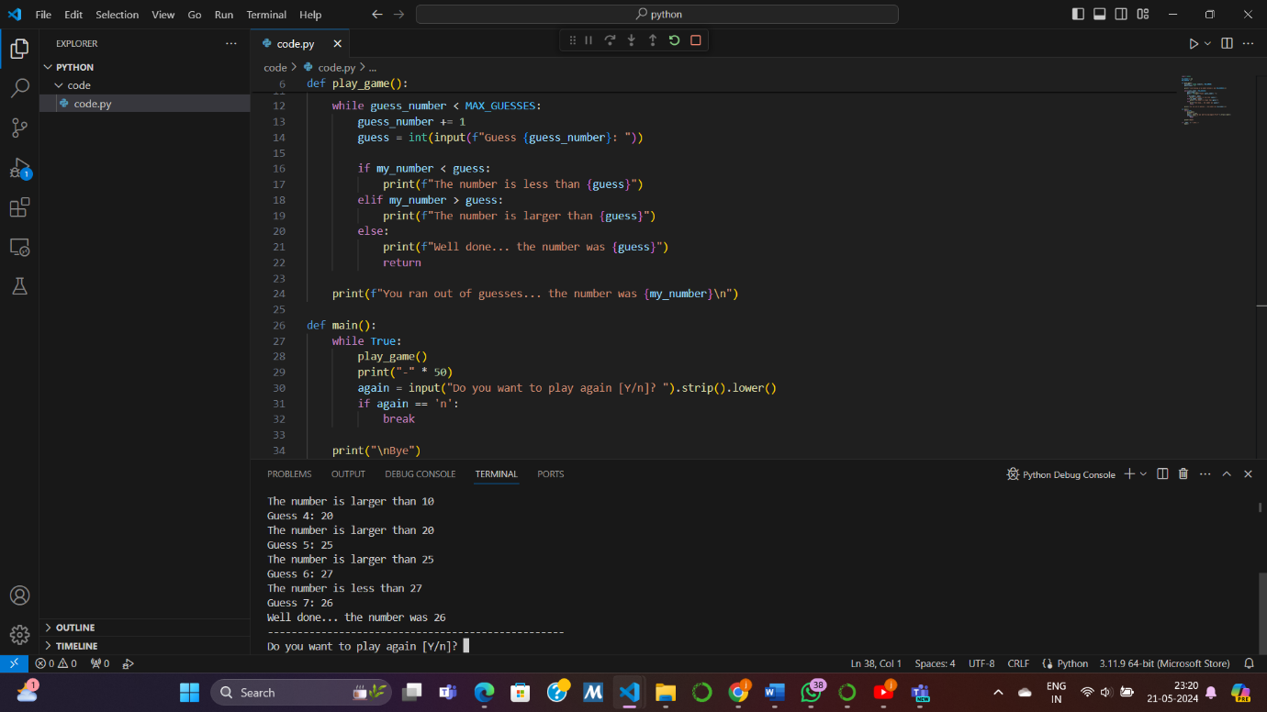
Reflections:
• How do you know you have achieved the learning goals?
I read through the module, implemented all that was explained and also did some extra research about python and its applications, syntax and commands. Was able to execute this program successfully.
• What is the most important thing you learned from this and why?
The most important thing I learned from this task is the practical application of fundamental programming concepts in Python. Building a simple guessing game like this helped solidify my understanding of how to structure a program, handle user input, and implement logic flow.
• How does the content or skills learned here relate to things you already know?
This task likely relates to things I already know as one that I already have studoed python a little during my high school and two that I have another unit ‘data science and artificial intelligence’ which is for now based completely on python. Concepts like variables, loops, conditionals, and functions are common across various programming languages, so transitioning to Python from another language is a little easier.
• Where or when do you think it will be useful?
This newfound knowledge and skill can be useful in various contexts. For example, I can use Python for web development, data analysis, scientific computing, automation, and much more. Understanding the basics through exercises like this lays a solid foundation for tackling more complex projects and exploring advanced Python features and libraries.

